J.D. Nicoud, Mouette 5
CH-1092 Belmont, Switzerland
Tel ++41 21 728-6156, Fax ++41 21 728-6157
Email info@didel.com www.didel.com

www.didel.com/slow/mirted/Mim3.doc

Mip3 and Mim3 - a 3-channel miniature ESC circuit or IR receiver

Mip3 and Mim3 are 0.27g circuits that decode the PPM or IR stream and control two bidirectionnal channels for 70 Ohm Birds, and one unidirectionnal channel, max 1 Amp. Voltage for the birds is the same as for the processor, 3 to 6V. Voltage for the propeller is maximum 12V. A LED on the circuit blinks when a signal is received.
Mim3 decode the IR stream crated by a TED or TedRa IR transmitter. It replace the MIR3 MIR4 MIR5 family with better performances. The IR sensor adds 0.3 to 0.45g.
Mip3 suppose you can pick the signal at the output of the radio receiver, before the decoding for the generation of servo or combo signal. Nick Leicht has the lightest receiver
(0.3g), that allows for a less than 0.6g three channels combo.

Mip3 and Mim3 are available for the cost of 42 CHF ( ca 27 Euros or 34 USD).

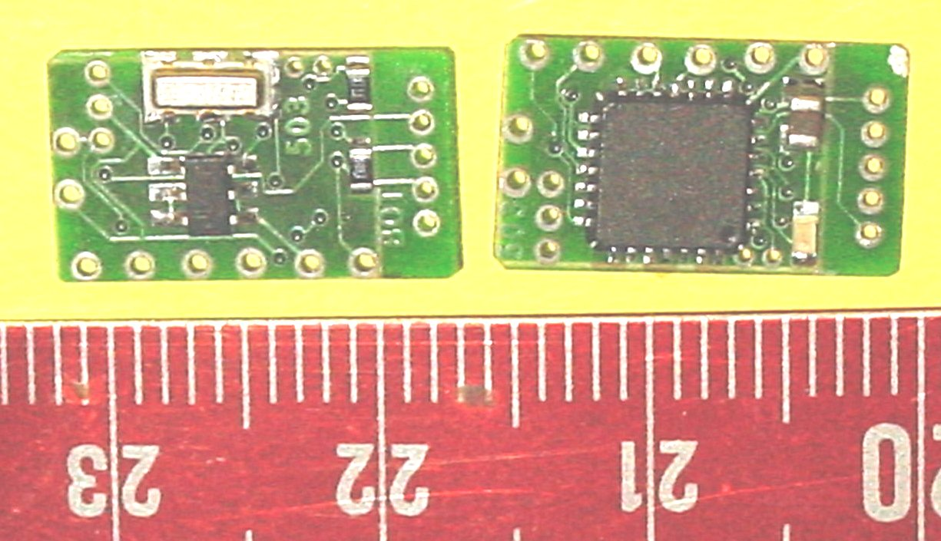

Mip3 – Two bidirectionnals channels (0,1) and one unidirectionnal channel (2)  Mim3 – Same for IR control  IR format compatible with TED and TedRa IR transmitters | 