CH-1092 Belmont, Switzerland  Tel +41 21 728-6156, Fax 728-6157  Email info@didel.com, www.didel.com | 
File www.didel.com/slow/pricelist/doc/GbKit2.doc

Gearbox kit for very slow flyers
Assembly instructions for two stages boxes for small motors

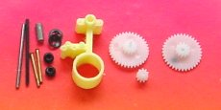 | 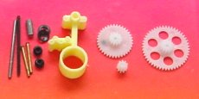
xR12 reduction 1:12 x=motor 4,6,7mm  G309, G336-82 and G336-95 gears | xR16 reduction 1:16 x=motor 4,6.7mm  G309, G336-82 and G348-95 gears
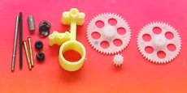 | 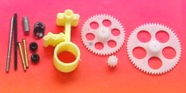
xR21 reduction 1:21.3 x=motor 4,6,7mm  G309, G348-82 and G348-95 gears | xR27 reduction 1:26.6 x=motor 4,6,7mm  G309, G348-82 and G360-95 gears
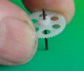
- steel shaft not supplied for these boxes -

The main piece of the kit consists of the precision plastic part, with its 1.00 mm brass bearings. There are two choices for the shaft, a CR 0.95 to 0.98mm light axis and a 0.98mm steel axis. We experimented CR does not wear. Press the gear onto the shaft as shown.
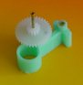
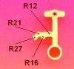
The intermediate gear is maintained by a 0.80mm rivet, to be inserted in the adequate bore (see picture left). Put the rivet in the gear with the 0.82mm bore, and press well in the hole direction.


Now you can assemble the main shaft. Slide the provided “perl” on the back end of the shaft as a washer, and next the Quicklock fastener, centered and depressed with the extermity of your digit. You get one more pearl and fasterer in case you loose one.

Install the pinion gear on the motor. For 4 and 6mm motors, the first part of the gear slides freely on the axis (0.71 and 0.81 mm bore on one side). Put the smallest possible drop of thin cyano at the middle of the motor shaft, and slide quickly the gear as far as possible, without any important axial effort on the motor axis. It should immediately fit firmly.
For motors with 1mm axis, the gear has a 0.97 mm and must be press-fitted on the axis. For a 7mm pager motor, axial effort must be avoided. Either you follow our recommendations for maintaning the back of the motor axis, or you ream out the gear to 1.00 to 1.01 mm and use some cyano to maintain the gear.

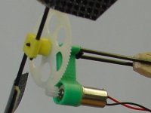
Slide the motor into the gearbox and check that the fit is snug and the gear engages freely with a minimum of play. If the motor is loose, don’t glue it, but put a thin layer of cyano inside the bore, and hold the motor by friction only.
Put a small drop of good quality fluid oil on all the axis.

The gearbox can be attached to the fuselage with two 1.4mm carbon rods distant of 5.5 mm. Again, if the carbon rod is loose, don’t glue it, but put some cyano to increase its diameter. It is convenient to reuse the same motor for different planes.

The 4Rm, 6Rm, 7Rm kits include all gears and 4 axes to build any of the 4 boxes above, if you want to experiment until you have found the best match with some existing propeller. The intermediate gear must me moved to a next position when the ratio is changed, but several insertions are possible without any problem (stay well in the axis).

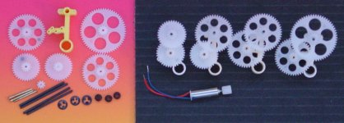
4Rm multiple gearbox kit
July 29.2002

