b CH-1092 Belmont, Switzerland  Tel +41 21 728-6156, Fax 728-6157  Email info@didel.com, www.didel.com | 
File www.didel.com/slow/wiring/Plugs.doc

Connectors and wires for ultra-light slow flyers (ULS)
JST connectors are widely usd on miniature radio receiver, but their weight encourages modelers doing ultralight models to unsolder them and connect wires directly. A major drawback of the JST connector is both the wire, which need to be of a size compatible with the crimp connectors of the JST, and the need of a crimp tool. Crimping the wire is a good solution, but an expensive tool must be bought for doing it correctly. | 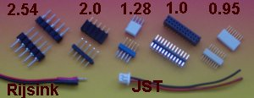  Fig 1. Several available connectors

Connectors at a pitch down to 0.8mm mm exists; they are very expensive, and/or are optimized for interconnecting board, that is many contacts and SMD pins on which it is not easy to solder wires in a reliable way. The 1mm single-in-line connector we have been using in several projects weights 0.055 and 0.08g (male and female 4 pins), and costs more than one USD per pin.

The requirement for an ULS connectors are the following:
- ultralight male and female connector
- possibility to solder directly the wires
- low price
We assume that the modeler has a small soldering iron and is not afraid soldering 36 AWG (0.12 mm). An adjustable iron is required with soldarable wire, the insulation of it is melting at 400 degrees. Otherwise, it is necessary to strip the wire with a sharp cutter, and it is not easy with these small wires to go around the wire to strip it all the way.

The solution proposed by DIDEL has an excellent price/weight/flexibility ratio. Rather standard low cost connectors are used for the female connector, and very light pins are cut out of 0.30mm CuSn (Copper-Berillium) wire. The weight budget is the following:
4-pin male plug 0.02g
4-pin female plug 0.18g (0.043 g for a single pin)
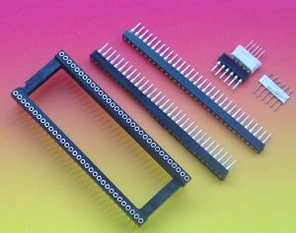
We prefer to have male pins soldered on the PC boards. The propeller motor and the actuators are equipped with female connectors; if the connectors are found too heavy, wires can be soldered directly, but then debugging is less easy. The 9-gram F0 has connectors for the motor and propeller.

Pitch is standardized to 2mm, in order to be compatible with the heavier connectors from Samtec (4-pin male 0.018g, 4-pin female 0.026g) and probably other manufacturers. The low number of pins and flexibility of the support of the male pins accepts pitches of 1.8 to 2.00 mm, and is compatible with the low cost connectors we use.
Fig 1. 64 « shrink » socket, extracted female connectors and male connectors

Female connector ¨  Shrink 64-pin sockets have been defined 20 years ago as a first step toward the miniaturization of microprocessors (Fig 1). They are still available, for less than 3 USD a piece (10 cents per contact), and their pitch of 1.78mm. Some work is required to cut and grind the connector to get strips that can be cut at the correct length (see picture). If a 0.2mm thick circular saw is not available (Proxon has the blades) a plyer and some sand paper will get the same result, with one pin lost at each cut. | 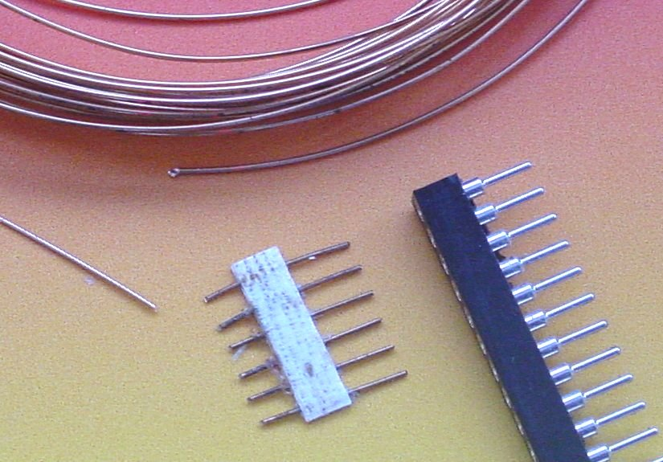  Fig 3 Male and female 1.8mm pitch connector

Male connector

A male connector strip is prepared by inserting 8 mm rods of 0.3mm CuSn in an female connector strip (figure 3). Two balsa strips 1mm thick, medium to hard grade, are glued on each side of the rods and hard pressed to a total thickness of less than 1mm. One can use white glue, but the wire do not stick very well inside the balsa. Supepathic glue may be better. Do not use CA, the female connector will be permanently glued to the male you build.
We proceed the following way (figure 4):
- Cut the pins and insert them in a strip of 5-10 female pins
- Prepare two strips of 1.2 to 1.5mm soft balsa of the corresponding length, plus several mm
- Place the balsa strip in place and press a little on the vice. Adjust the position and press to the maximum; the Balsa may decrease its thickness by a factor 2 or 3.
- Remove after one or two hours

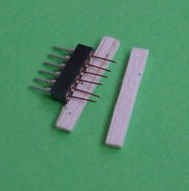 | 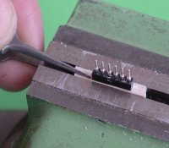 | 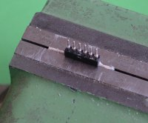

Fig 4 Assembly of a male connector with 0.3 to 0.35 mm CuBe wire
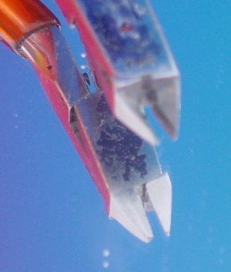

The CuBe wire for the male connector must be cut with a very sharp scissor, or with an expensive small plyer with a flat side (see picture). On one side the wire is cut perpendicularly. On the other side, there is an important deformation and this side should not penetrate the female connector: it my damage the inside springs.

Fig 4 A good plyer with a flat face

Copper wire

Solderable magnet wire is mainly used for coils, but its advantage for us is that the insulation melt at about 360-400 degrees (ajust the soldering iron to the hottest value).
Copper wire is heavy, and it is not worth using the battery power to heat it. The best trade-off has to be used, as shown in table 1.

 | Wire diameter | Resistance/m | Weight/m
AWG 36 | 0.12mm | 1.4 Ohm/m | 0.12 g/m
AWG 33 | 0.18mm | 0.67 Ohm/m | 0.24 g/m

Table 1
Thickness of wire must be such that the voltage drop is acceptable, that is less than 0.1 volt. To get an idea, let us consider two kinds of equipment: a BIRD actuator (50 mA) and motors (200 mA). Usually, the BIRD is at some distance of the receiver, but the propeller is much closer. Table 4 shows that one should plan for a total of 0.1g for the wires, about the double for insulated wire of the same copper diameter.

Wire | Current | Length for 0.1 V | Distance | Weight
AWG 36 | 50 mA | 1.4 m | 70 cm | 0.08 g
AWG 33 | 200 mA | 0.7 m | 35 cm | 0.08 g

Table 2

Where to get the components

In order to simplify the life of ULS specialists, DIDEL proposes a connector kit which includes enough connectors and wire for the construction of more than three planes. | 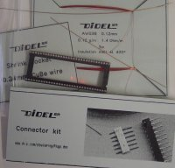
CW1 connector kit: 15 CHF, about 10 USD.
1 shrink 64 pin sockets
20 cm of 0.30mm CuBe wire
5 m of AWG36 - 0.12mm solderable wire

Examples of design
See www.didel.com/slow/mirted/Wiring.doc
Other examples with very small circuits:
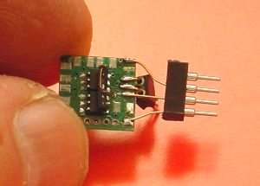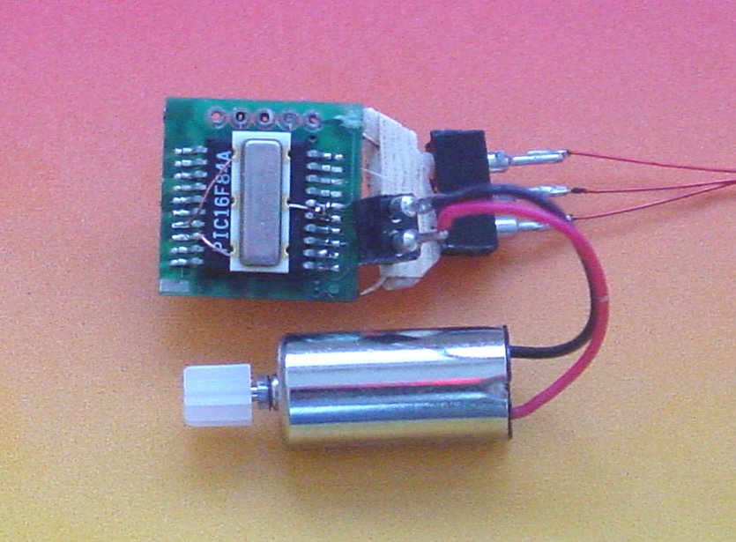
030212/jdn

